**Programming in Python** *Cyrus Nilsson*

The original scripts are attached with their respective number from the tasks, so you can run them on your own. Outputs are only included for more advanced tasks.

1. Modify the expression *print 5+3*2* to get a result of 16.

Answer: print 4+3*4

8. Print the following pattern using a while loop +, ||, +++, ++++.

Answer: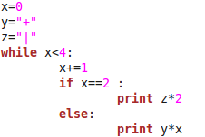

11. Write code to print all perfect cubes up to 2000.

Answer: 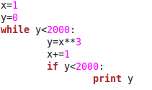

12. Write a Python program to print the multiplication table of 5.

Answer: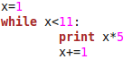

15. Write a Python program to calculate the area of circle.

Answer:

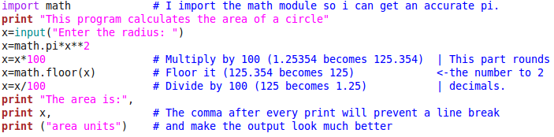

Output:

16. Write a program to divide an integer by another without using the / operator.

Answer:

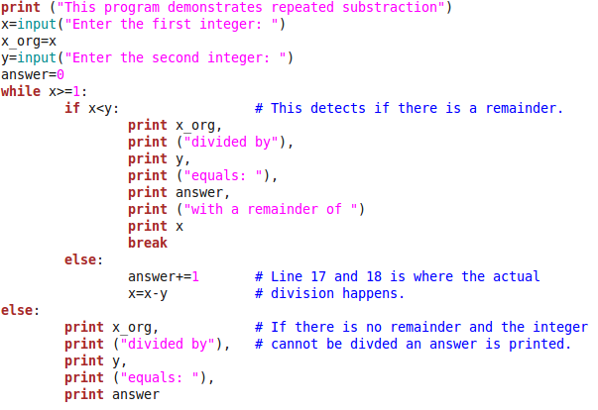

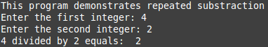

Output:

